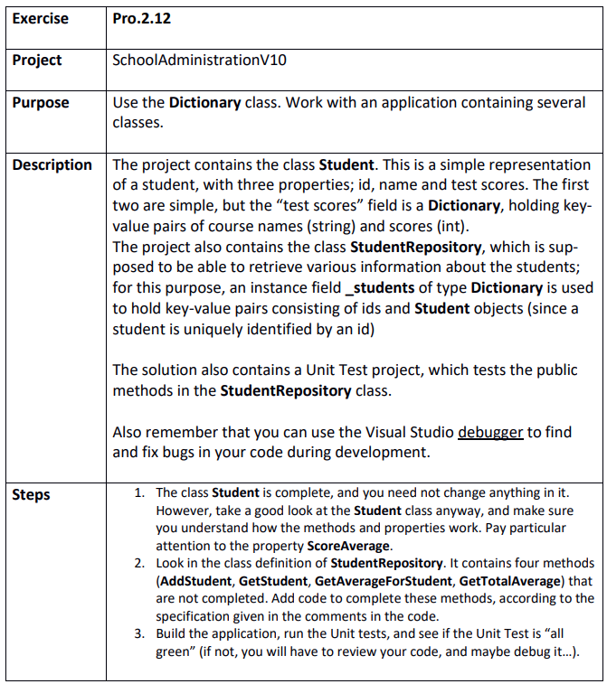

Step 1
SchoolAdministrationV10.sln

Step 2
